Project Title: NeoNova Lounge Chair
Theme: Retro Futurism-Inspired Custom Furniture Design

1. Research: Understanding Retro Futurism
Overview:
Retro Futurism is a design movement that merges mid-20th-century nostalgia with futuristic optimism. Originating in the 1950s–1970s, it visualized how people of that era imagined the future — influenced by the Space Age, atomic energy, and technological progress.
Aspect | Details
Historical Context | Emerged during post-war optimism and the Space Race. Reflected fascination with science and technology.
Design Philosophy | “The future as imagined in the past” — blending mid-century aesthetics with sci-fi inspiration.
Common Elements | Curved lines, bold geometry, chrome and metallic finishes, neon lighting, atomic motifs.
Influences | Space exploration, mid-century modern design, industrial technology, 1960s sci-fi films.
Key Visual Features:
- Streamlined and aerodynamic forms.
- Glossy, reflective materials like chrome and fiberglass.
- Playful, vibrant color palettes with metallic undertones.
- Use of LED or neon lighting to create a futuristic glow.

2. Color, Shape, and Form Analysis
Design Attribute | Retro-Futuristic Characteristics | Chosen for Project
Color Palette | Metallic silver, turquoise, red, white, black | Silver, teal, matte black, and neon orange accents
Shapes | Rounded, pod-like, geometric symmetry | Curved seat form, circular base
Forms | Floating, cantilevered, sleek outlines | Floating metal frame with continuous curve
Texture | Glossy plastics, brushed metal, vinyl | Chrome and metallic vinyl finish
Lighting Mood | Soft neon or backlit glow | LED underlighting beneath armrests

3. Concept & Sketch Development
Furniture Type: Lounge Chair
Concept Name: NeoNova Lounge Chair
Concept Statement:
A futuristic yet nostalgic seating piece inspired by spacecraft interiors and 1960s optimism about space travel. Designed for comfort and visual intrigue, the NeoNova Lounge Chair combines flowing curves, reflective metallic surfaces, and subtle LED lighting to embody the essence of retro futurism.
Design Features:
- Curved backrest shell in fiberglass with chrome finish.
- Upholstered metallic vinyl seat with geometric stitching.
- Integrated LED strip under armrests for accent lighting.
- Floating circular base resembling a levitating platform.
Room Application:
- Living room corner, creative lounge, or studio space.
- Dimensions scaled for ergonomic comfort and balanced visual proportion (approx. 900mm height, 750mm width, 850mm depth).
4. 3D Modeling in SketchUp
Details to Include:
- 3D Model of chair with realistic materials and lighting.
- Background room setup in retro-futuristic interior (rounded walls, neon trim, glossy floor).
- Views to render:
  - Front Perspective
  - Top View
  - Side Close-up (highlighting frame and upholstery)
  - Full Room Integration
Material | Finish/Texture | Color
Chrome Metal | Reflective Polished | Silver
Fiberglass Shell | Gloss Smooth | White
Upholstery Vinyl | Metallic Patterned | Teal
LED Strip | Diffused Light | Neon Orange Glow

5. 2D Drawings in AutoCAD
Required Drawing Sheets:
Sheet No. | Description | Scale | Content
1 | Overview & Title Block | 1:10 | Isometric + Project Title
2 | Orthographic Views | 1:10 | Front, Top, Right Side Views
3 | Detail Drawings | 1:5 | Joinery, Upholstery seam, Frame Connection
4 | (Optional) Exploded View | 1:10 | Component breakdown and materials
Annotations:
- Include all key dimensions and part labels.
- Add callouts for materials, finishes, and lighting locations.
- Ensure sheet has consistent layout, north arrow, and title block.

6. Concept Presentation Board (36” x 24”)
Layout Components:
- Project Title & Concept Name
- Design Brief (short text explanation)
- Inspiration Board – 4–6 reference images of retro futurism.
- Concept Sketches & Development Process.
- 3D Model Renders – main and close-up views.
- 2D AutoCAD Drawings – plan, elevations, and details.
- Material Palette & Color Samples.

Inspiration:
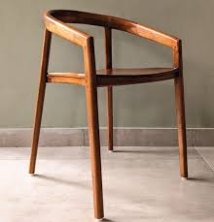

Sketch:

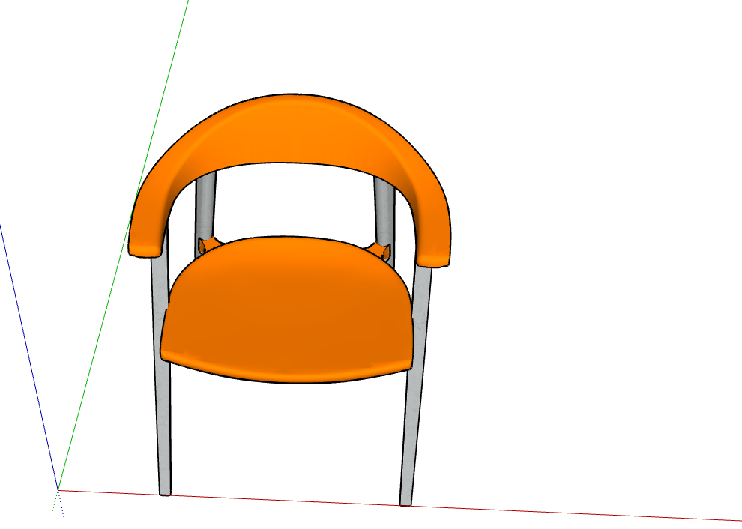

AutoCAD design and Layout
Top:
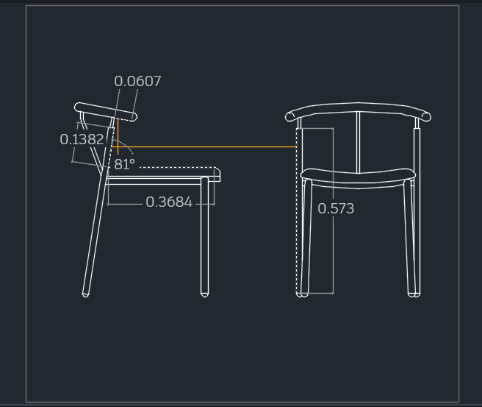

Left
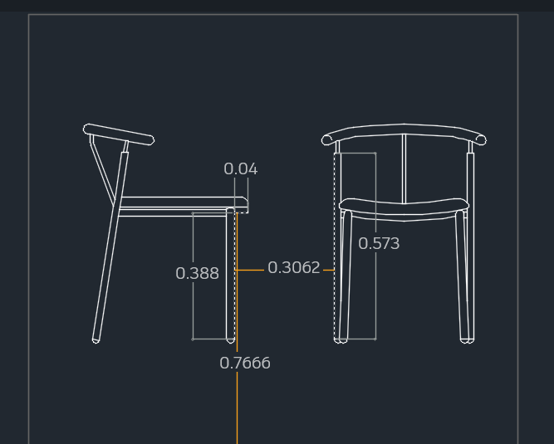

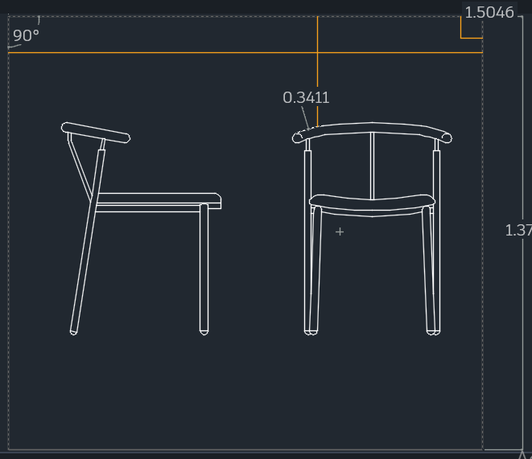

Front
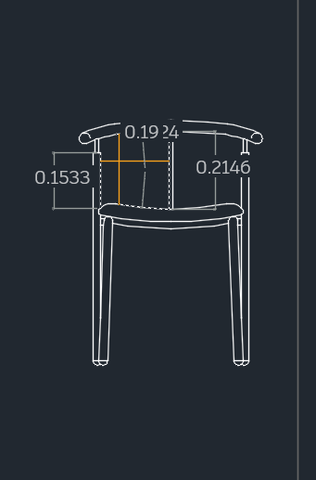

Side
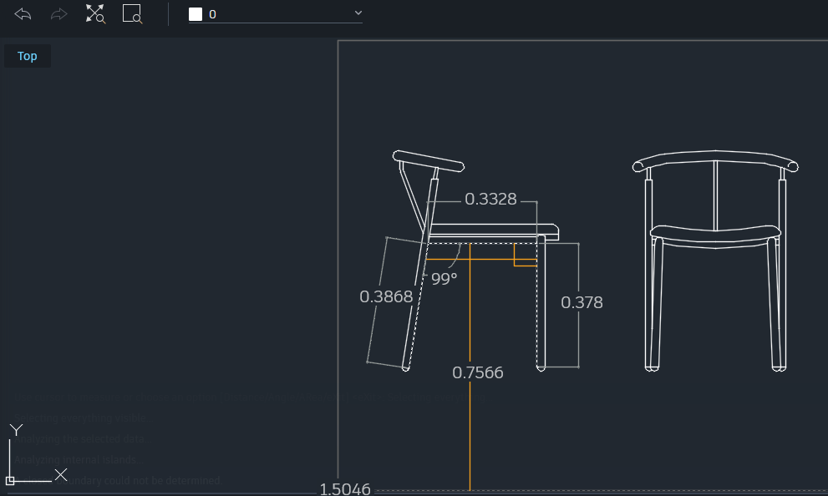

Bottom:
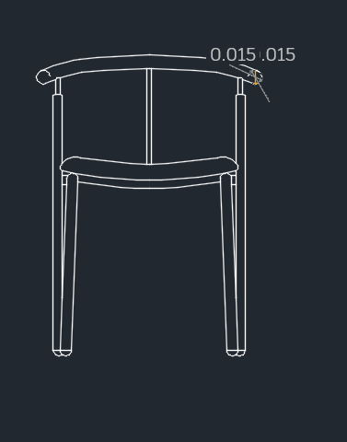

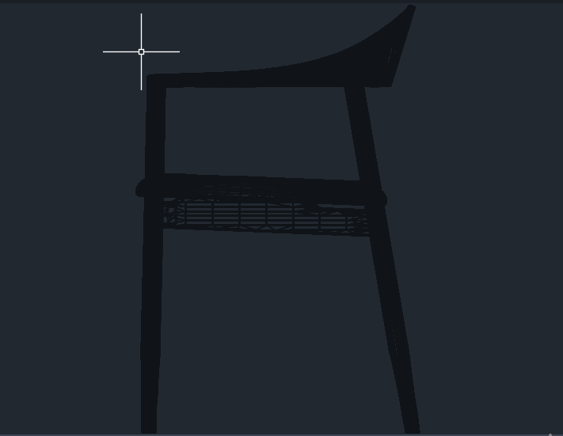

Design Brief:
The NeoNova Lounge Chair captures the essence of retro futurism by merging mid-century modern design with the imaginative aesthetic of space-age innovation. Its curved form and chrome finish reflect movement and optimism, while integrated LED lighting symbolizes modern adaptability. The design aims to offer both comfort and visual excitement, fitting seamlessly into futuristic-themed interiors.

References
Pandey, J., & Shoukry, Y. (2022). Practical Autodesk AutoCAD 2023 and AutoCAD LT 2023: A beginner's guide to 2D drafting and 3D modeling with Autodesk AutoCAD. Packt Publishing Ltd.
Shih, R. (2022). AutoCAD 2023 Tutorial First Level 2D Fundamentals. SDC publications.

